Jon Doretti #1887910

CSC 333

Professor Eric Schwabe

Assignment 1

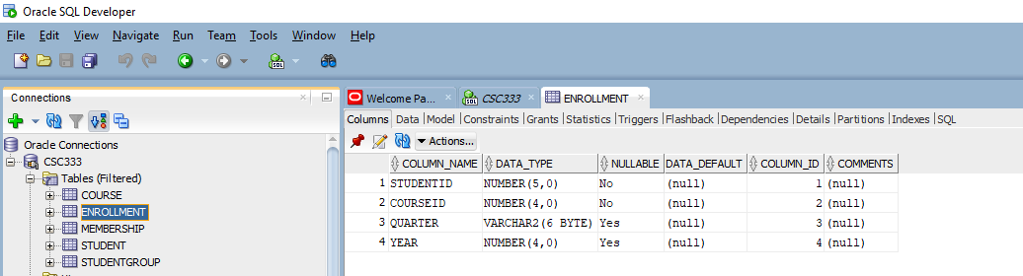1)

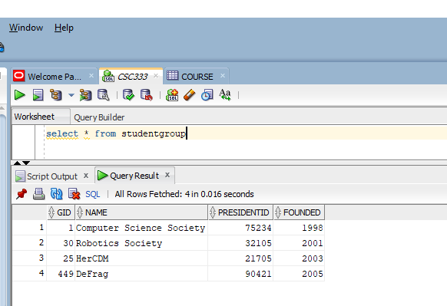2)

3) a) The combination of RouteID and DriverID are the primary keys for ASSIGNMENT.

b) RID is the primary key for ROUTE.

c) TID is the primary key for TRUCK.

d) RouteID is the foreign key for ASSIGNMENT.

e) TruckID is the foreign key for ROUTE

f) TRUCK does not have any foreign keys.

g) ROUTE(NULL, New York, Los Angeles, 31) – would not add because NULL cannot be added in the primary key; therefore violating entity integrity.

h) ROUTE(R077, Seattle, Huston, 12)

i) ASSIGNMENT(R088, 383227, 12-SEP-21) – violated referential integrity because R088 is not added into table ROUTE

j) ASSIGNMENT(R066, 383227, 12-SEP-21)

k) ROUTE {(R011, Chicago, Miami, 12), (R033, Chicago, Los Angeles, 31), (R055, Los Angeles, Miami, 45)} – these tuples in ROUTE cannot be removed as all tuples in ASSINMENT need to reference one of these three.